West & Middle Chinnock Community Plan

Survey Results and Action Plan

Contents:
Part A – Executive Summary
Part B – Survey Results and Analysis
Part C – Proposed Action Plan

Part A

Executive Summary

Local Solutions for Local Issues

"Our vision for West and Middle Chinnock is of a socially cohesive and mutually supporting rural parish. A parish with adequate infrastructure, that respects the value of the surrounding farmland and natural landscape and offers essential services, recreation, employment and housing opportunities for people of all ages and income levels.”

In 2015 the Parish Council identified the need for the community of West & Middle Chinnock to develop a Community Plan. This would set out how the community wanted the parish to develop, and would provide a catalyst to extract support from appropriate funding providers.

A ‘roadshow’ in January 2016 was well attended and an independent steering group was set up, outside the control of the Parish Council: The West and Middle Chinnock Community Plan Steering Group members are Bill Mannering, Shaun McMillan, Mark Bennett, Jane Naughton, Gill Langford, Neil Cochran and Raymond Bailey.

This steering group, with help and advice from South Somerset District Council, developed a Survey Questionnaire which was distributed to every property in West & Middle Chinnock. A very good return rate of 74% means that the findings are a good representation of the overall community’s feelings and aspirations.

This document provides an overview of the results of the survey, and identifies a proposed action plan to take the ideas forward.

Overall Survey Conclusions
- A very good return rate of 74% was achieved, with responses from 371 individual people.
- There is a huge amount of detailed information which can be analysed in detail and used to support specific projects or purposes as and when they arise. In particular, results can be broken down by respondent age group or by village location, where appropriate. And results from one question can be correlated with results from another if necessary.
- The survey indicates a good community spirit in West & Middle Chinnock and a high degree of interest in village events.
- The Recreation Ground was seen as the most important and most used facility, closely followed by the Village Hall, the Pub and the Community Playground.
- Speed limits and Neighbourhood Watch would be welcomed by a large majority, but street lights would not be welcomed.
- The car is easily the most used method of transport for going outside of West & Middle Chinnock; there is some limited interest in using buses more often if a better service was available.
- Providing better equipment at the Recreation Ground would be the most popular improvement to village facilities, followed by better footpath access to the Recreation Ground, revamping the current Village Hall, and setting up a Youth Club.

Action Plan Summary

The proposed Action Plan would set in motion a number of initiatives:

- General – Make the survey results known to the Parish Council to utilise as appropriate.
- Recreation Ground Development – Includes facilities at the Rec and access to the Rec. This will require a committee to be formed.
- Village Hall Revamp – The Village Hall Committee is already developing the hall.
- Online & Notice Boards – These are not greatly used for information; ways to increase use/awareness should be considered.
- Youth Activities – Includes the formation of a Youth Club. This will require a committee to be formed, involving youths.
- Neighbourhood Watch – The existing scheme should be promoted more extensively.

Part B

Survey Results and Analysis

Introduction
The objective of the survey was to elicit views on a range of community issues from as many residents as possible, of all ages. The topics addressed are as follows.

- Demographics – About Your Household
- Village Activities & Community – What’s Happening
- Transport – Getting About
- Health & Wellbeing
- Employment
- Community
- Housing

Questionnaires were delivered to every household in West & Middle Chinnock (total of 221 Precept Properties). The questionnaire was designed to enable each individual person in a household to provide their own answers. Individuals are referred to as ‘Respondents’ throughout this document.

The following sections consider each topic area in turn, presenting aggregated results charts for each individual question. Some brief discussion of the results is provided but there is a huge amount of further information in the survey which can be analysed in detail and used in future to support specific projects or purposes as appropriate.

These results sections are then followed by conclusions from the survey, and a proposed Action Plan is outlined in Part C.

Survey – General

Note: Not all individual respondents answered all the questions. The majority of percentages specified in this document indicate the percent of all respondents, not just those that answered a particular question. In some cases the percentage is the percentage of those that answered the specific question; in these cases the percentages are qualified accordingly.

- There were 164 questionnaire returns (= 74% of Precept Properties), with 371 individual respondents. This is a very good return rate.

- Respondents covered a good spread of ages; but note that 41% are aged 60 or over, and only 23% are under 25.

Demographics – About Your Household

Gender and Age

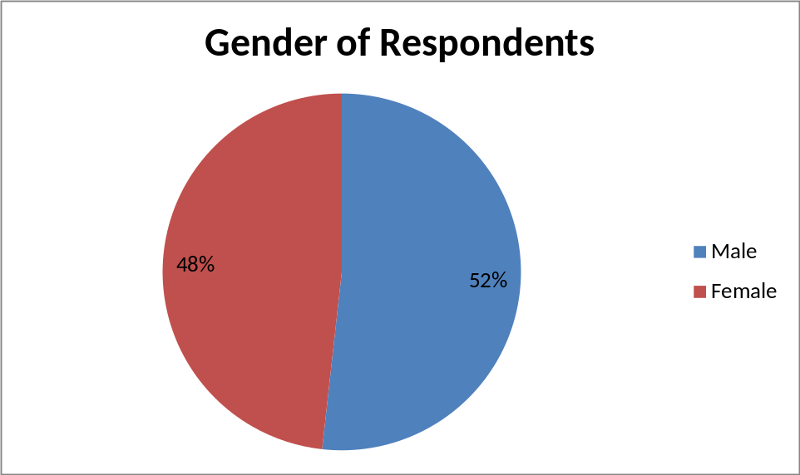

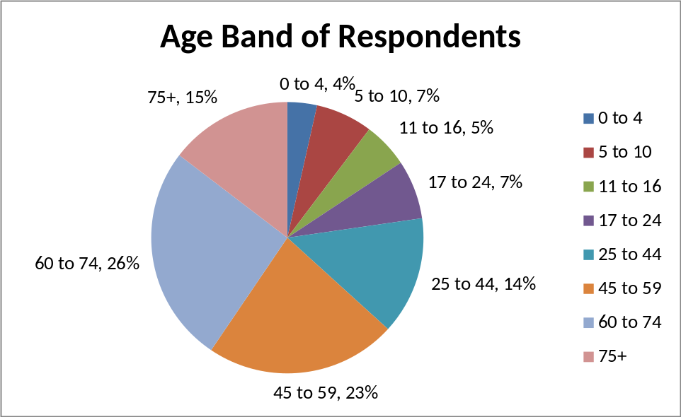

Individual respondents were fairly evenly split between male (192) and female (179). Although this is not unexpected, the age band results are interesting. Nearly 2/3 of all respondents (64%) are aged 45 and over, with 41% over 60. Only 16% are aged 16 and under, and 23% under 25.

Dwelling Details

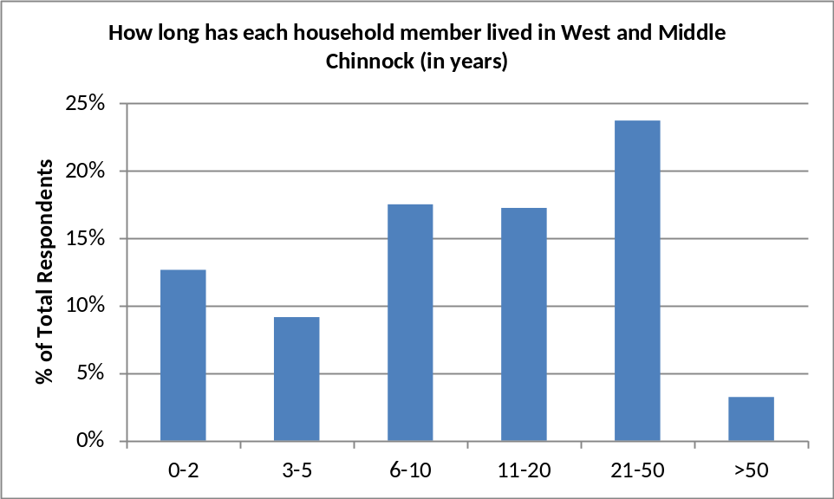

There is a good spread of periods that respondents have lived in West & Middle Chinnock, perhaps indicating a good mix of ‘newcomers’ and ‘old timers’.

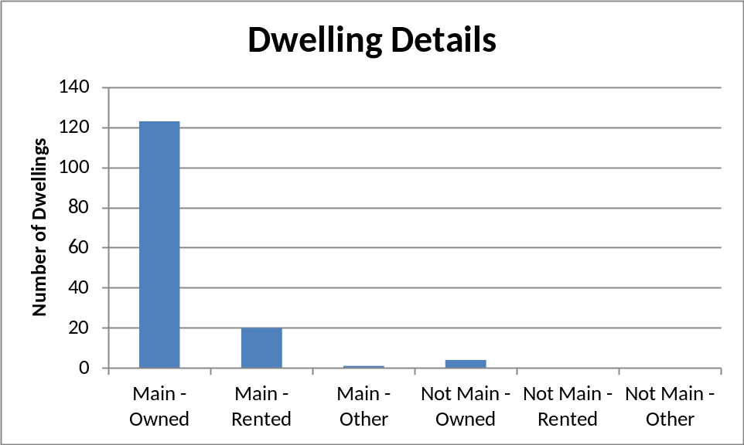

The vast majority of properties in West & Middle Chinnock are ‘main’ residences and owner-occupied. However, there may be more ‘not main’ residencies in the village since many of these could have been unoccupied or occupied as holiday lets during the survey, and consequently it is probably less likely that completed questionnaires would be returned.

Employment / Education Status

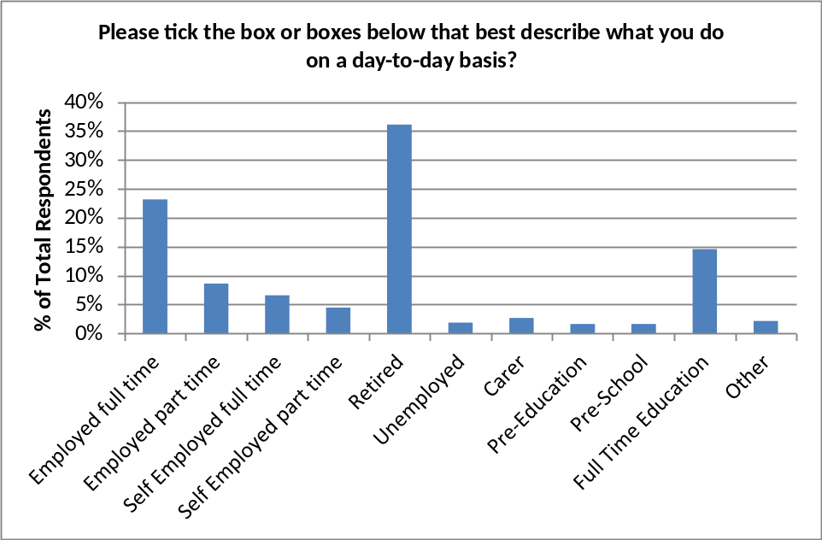

Note that for this question, respondents were permitted to select more than one category, and consequently the total sums to slightly more than 100% (actually 104%).

‘Retired’ is the most common description of day-to-day activity, not surprising given the age band demographics described in Section 2.1. Full time employment and full time education are the next most common categories. ‘Unemployed’ is at 2% of respondents, similar to the UK average.

Village Activities & Community – What’s Happening

Interest in Village Events

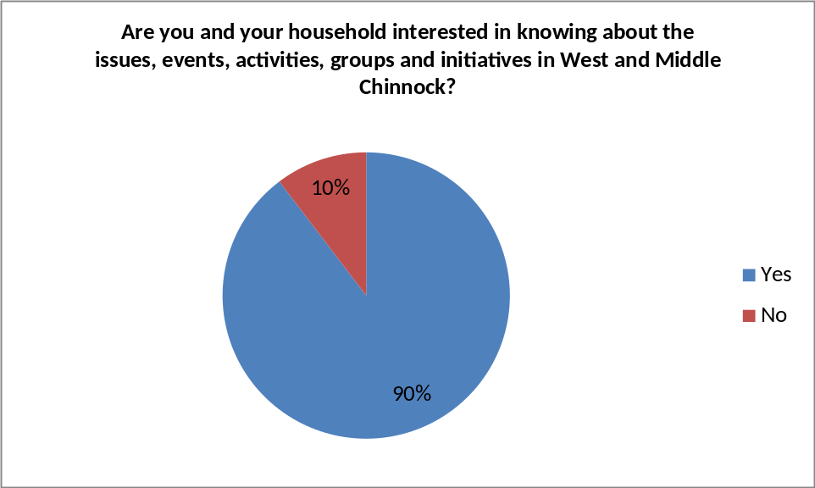

90% of respondents who answered this question are interested in village matters and activities. This equates to 84% of all respondents. 10% of respondents are not interested. This indicates a generally good community spirit (confirmed by Section 7.4).

Current Events

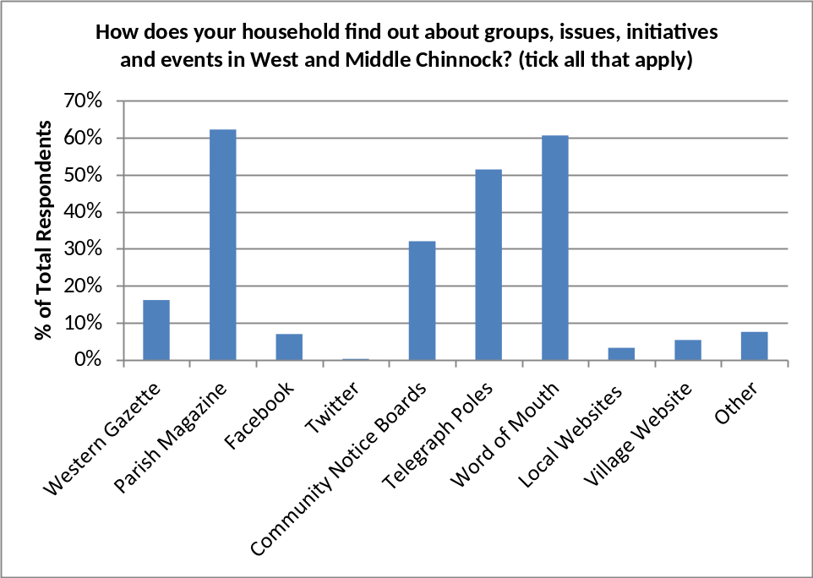

The most common means of finding out about village matters and activities are the Parish Magazine, word of mouth and posters on telegraph poles. Community Notice Boards are also used but not by as many respondents. Only 5% use the West & Middle Chinnock website.

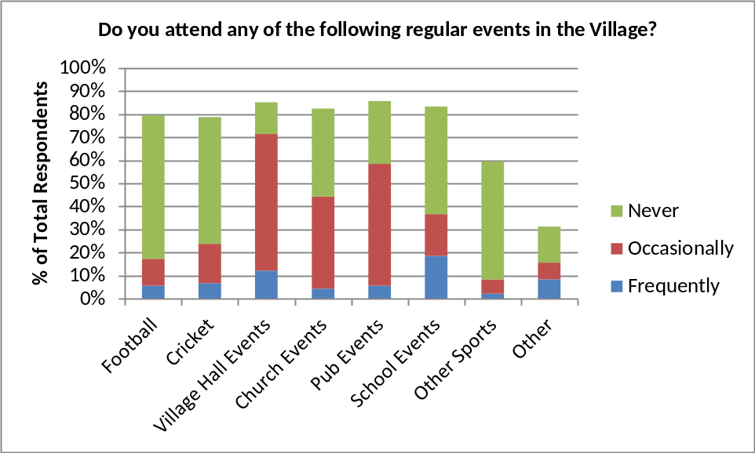

Asked about following or attending regular events, the options were ‘frequently’, ‘occasionally’, and ‘never’, leaving the respondent to self-define these terms. Some respondents did not answer this question; hence the totals for each event are less than 100%.

Combining ‘frequently’ and ‘occasionally’, the most followed events are those at the Village Hall, Pub, Church and School.

New Events

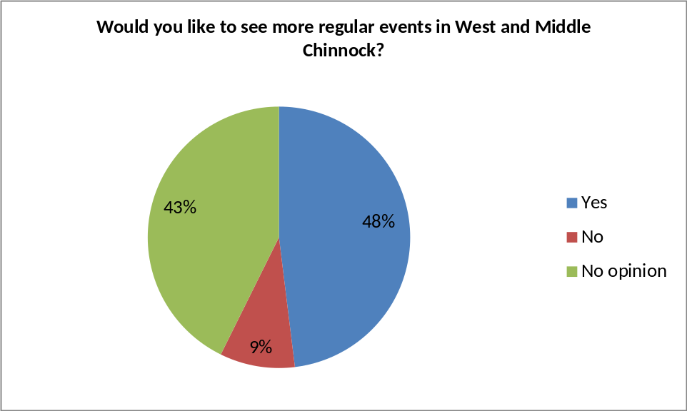

Following the question on current events, respondents were asked about future events. Nearly ½ want to see more events, and most of the rest have no particular opinion. Only 9% do not wish to see more events.

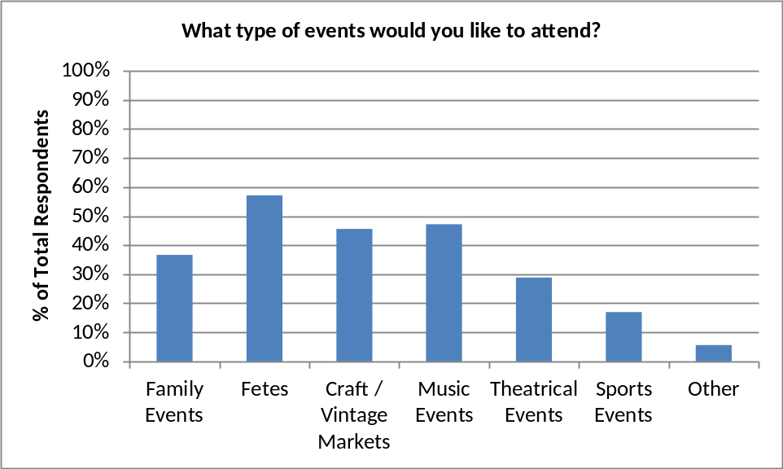

Of the specific extra events listed, there is a fairly even interest across all the options.

Transport – Getting About

Transport Within West & Middle Chinnock

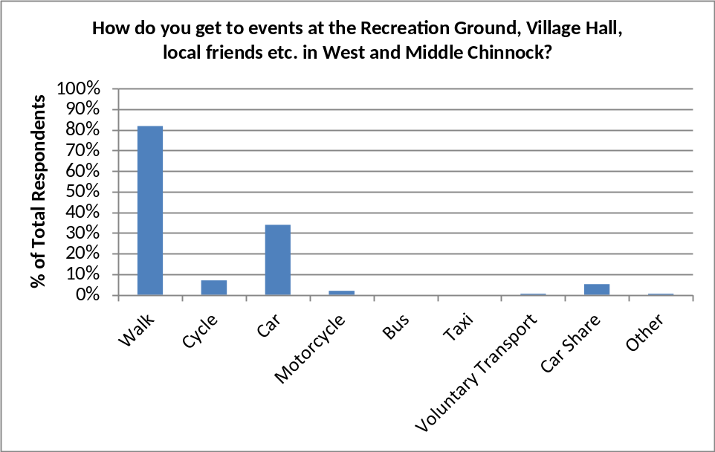

Walking and to a lesser extent cars are the main means of getting around West & Middle Chinnock.

Transport Beyond West & Middle Chinnock

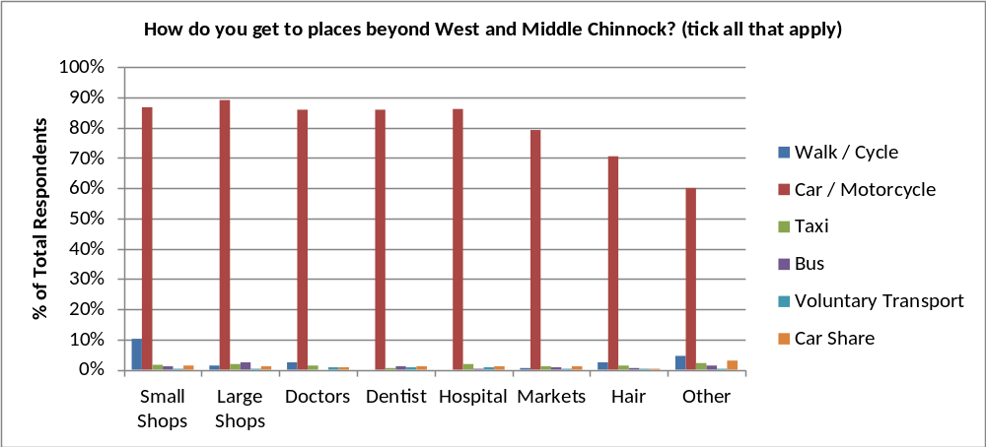

In contrast, to get to places outside of West & Middle Chinnock, the overwhelming majority of respondents use cars or motorcycles. Of the other means of transport and destinations, only walking or cycling to small local shops is used by more than a handful of respondents (specifically, 38=10% of respondents)
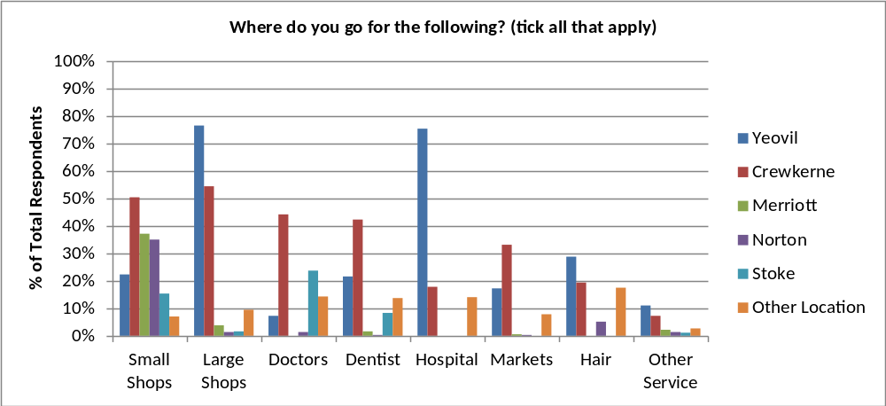

The location of services used is varied. Yeovil and Crewkerne are the main locations for large shops, but small shops are located widely; doctors and dentists are primarily in Crewkerne, and the main hospital used is in Yeovil.

Car Parking Problems

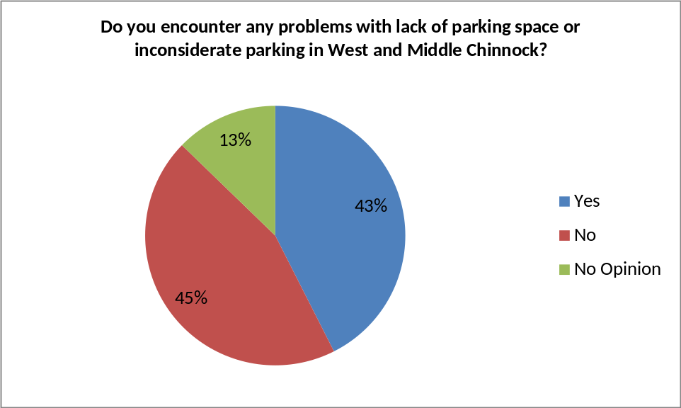

The issue of parking is evenly split between, with 43% experiencing problems and 45% not.

However, this is somewhat dependent on where in West & Middle Chinnock the respondents live (see below). The highest proportions of problems were identified by respondents from Higher Street, Lower Street, North of the River (including Haunts, Eastfield Lane) and Ridgway (plus Rickhay Rise and Hillview Close). Much lower proportions of problems were identified in Middle Chinnock, Scotts Way/Layne Terrace, and Duckpool Lane and Highfield.

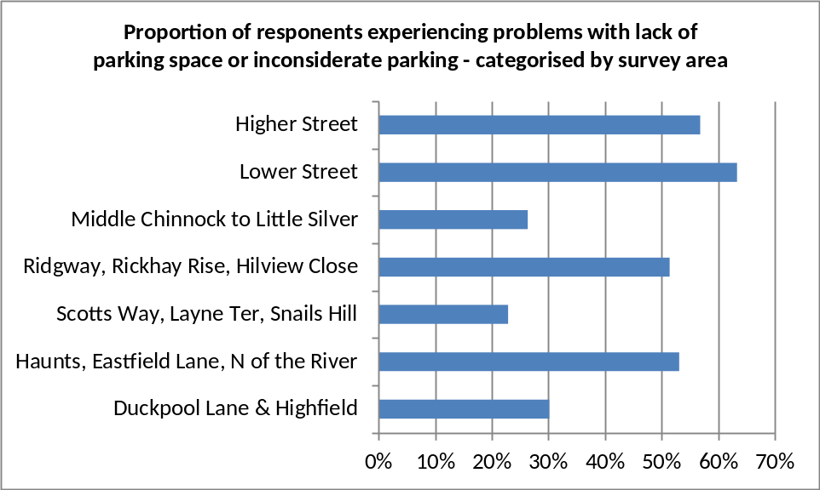

Transport Improvements

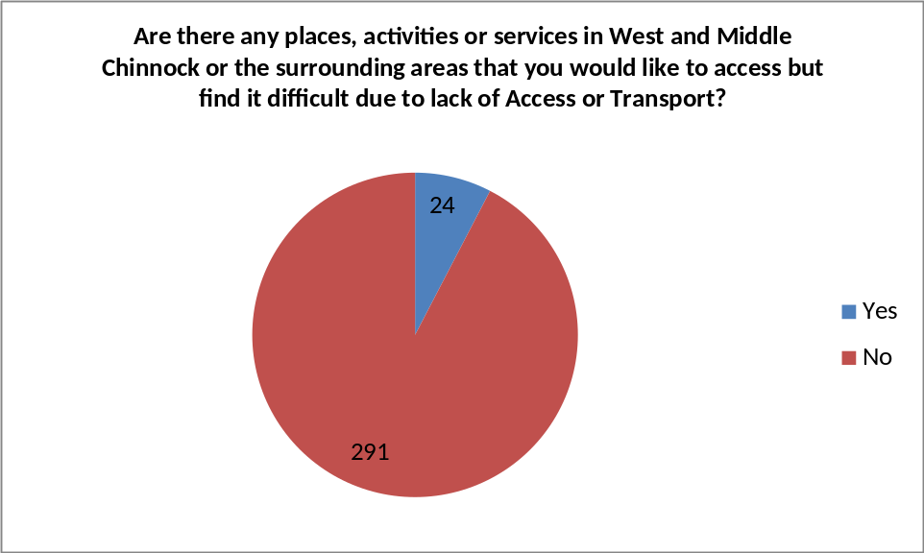

Assessing the need and options for improved transport, very few respondents (24=6%) experience difficulty in accessing activities and services due to transport.

Of the transport improvement options offered in the survey (see below), only improved bus service would be likely to be used by many; 30% of respondents would use improved buses at least monthly.
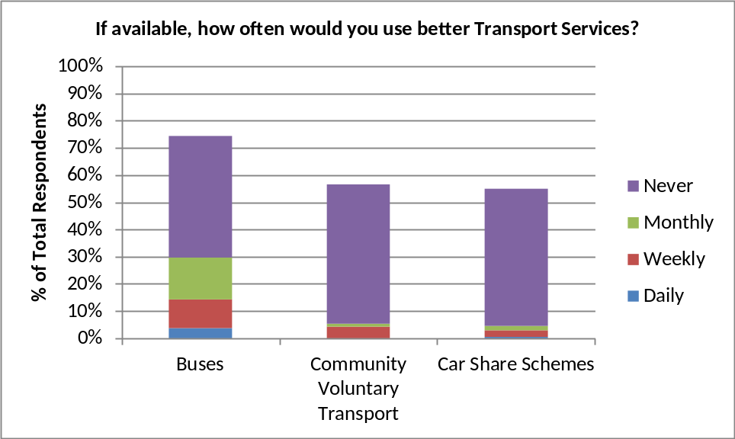

Health & Wellbeing

Crime

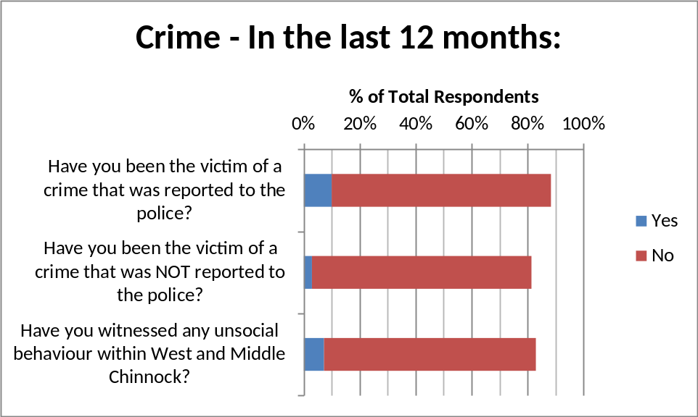

10% of respondents answered the question as having reported a crime to the police. However, from the comments and further details provided in the questionnaire returns, it is apparent that these reports were often well before the ‘last 12 months’ period specifically asked for in the survey. Whether 10% is considered high or low, it must be considered that it is spread over several years.

Making West & Middle Chinnock Safer

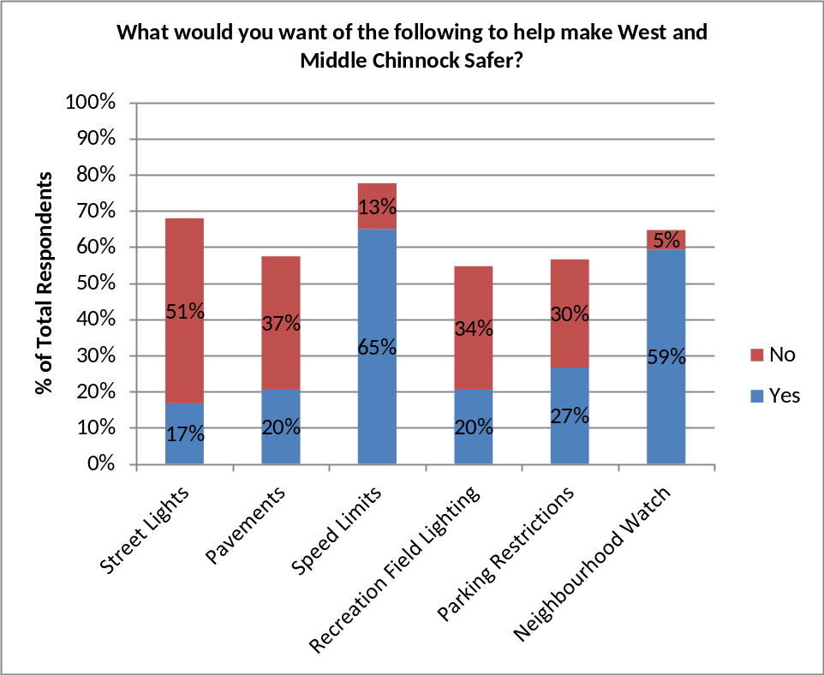

A number of specific options for making West & Middle Chinnock safer were offered in the survey, each with a yes or no response. Speed limits and Neighbourhood Watch are both very strongly supported. Street lights are strongly rejected by 3:1.

Pavements, Recreation Ground lighting and parking restrictions are quite evenly split although all three are on balance rejected.

Community Self Help

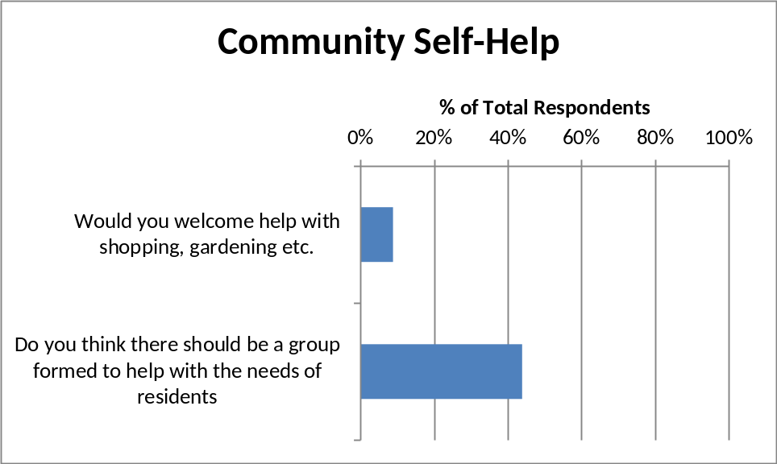

9% of respondents indicated that they would welcome community help and 44% indicated that a group to provide help should be set up.

Employment

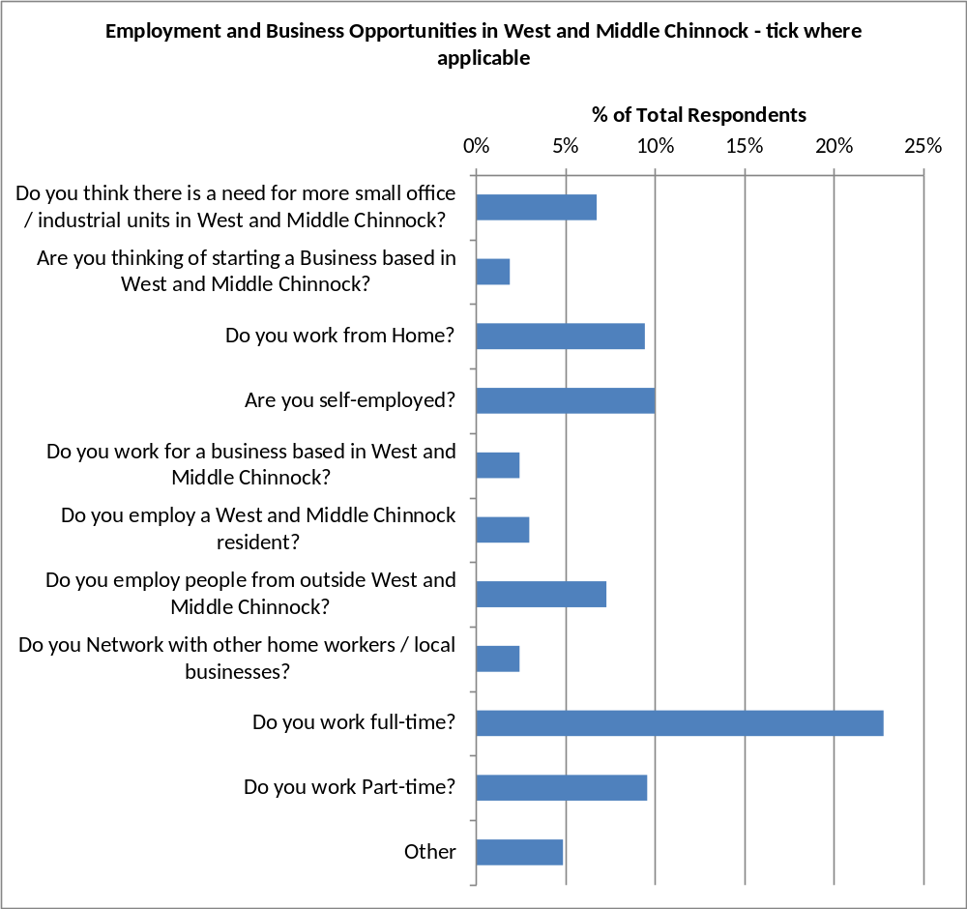

Community

Facilities
The following two charts consider a number of identified facilities within West & Middle Chinnock. First was the question of how important the facilities are to the community, and second was the question of how often they are used. These are then followed by a chart which shows what improvements the community would like to see to these facilities.

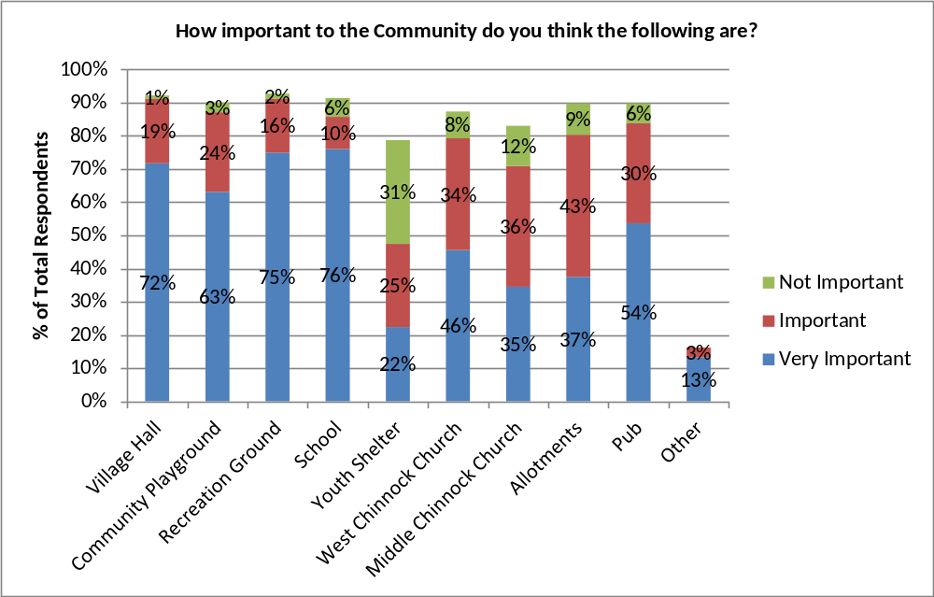

The majority of identified facilities are rated as ‘important’ or ‘very important’ by a high proportion of respondents. In particular, the School, Recreation Ground, Village Hall, Community Playground and Pub are rated as ‘very important’ by over 50% of respondents (up to 76% for the school).

Including ‘important’, the Allotments and the Churches are also highly rated. Only the Youth Shelter is rated ‘important’ or ‘very important’ by less than 50% of respondents.

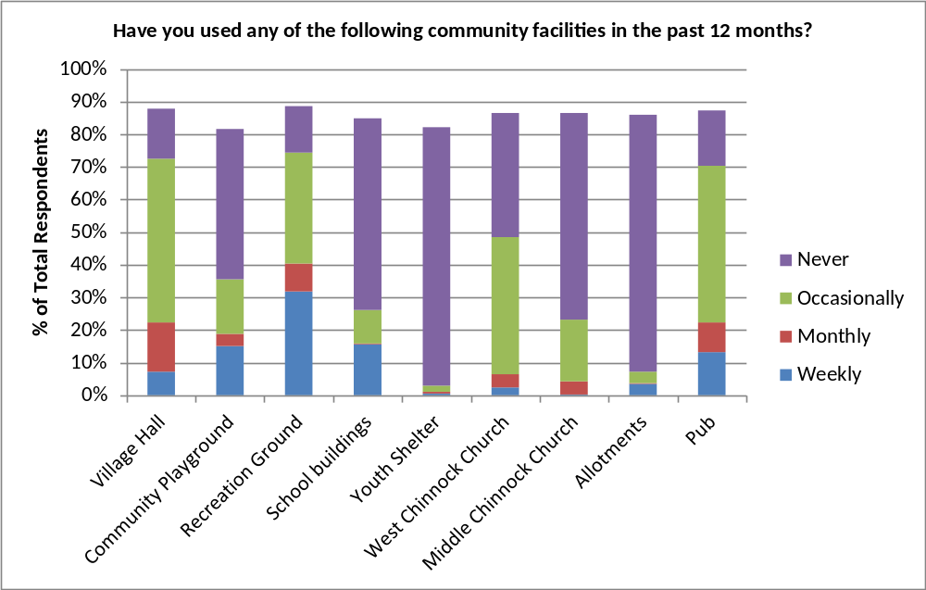

The Recreation Ground, Village Hall and Pub are the most used facilities, with over 70% of respondents using them at least ‘occasionally’, with the Recreation Ground being used ‘weekly’ by 32% of respondents.

Only the Youth Shelter and Allotments are used infrequently; around 80% of respondents ‘never’ use them. This may be expected: although the Allotments are well used by plot holders, these are necessarily limited in number; and the Youth Shelter is little known about and anyway would only attractive to a minority of residents.

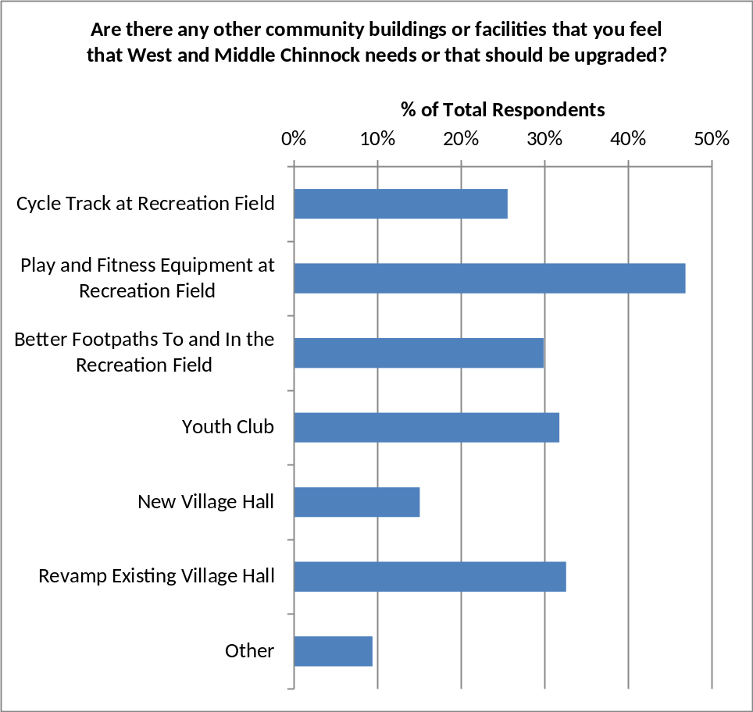

None of the identified improvements is supported by the majority of respondents, but better facilities at, and access to, the Recreation Ground is generally reasonably well supported. Setting up a Youth Club is also well supported.

Regarding the Village Hall, by around 2:1, respondents favour revamping the existing Village Hall ahead of building a new one.

Sports, Arts and Leisure Activities
The questions on activities asked what activities people currently take part in, what prevents residents taking part in activities, and then for a number of leisure activities, where do they do them.
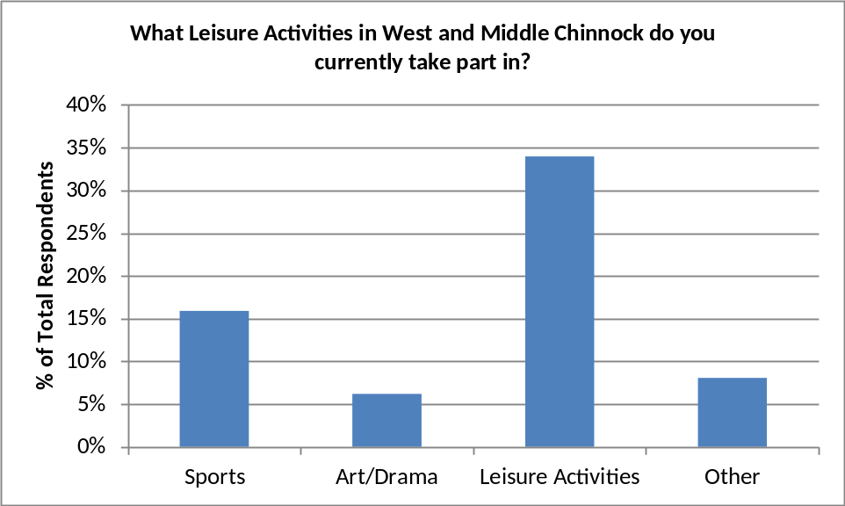

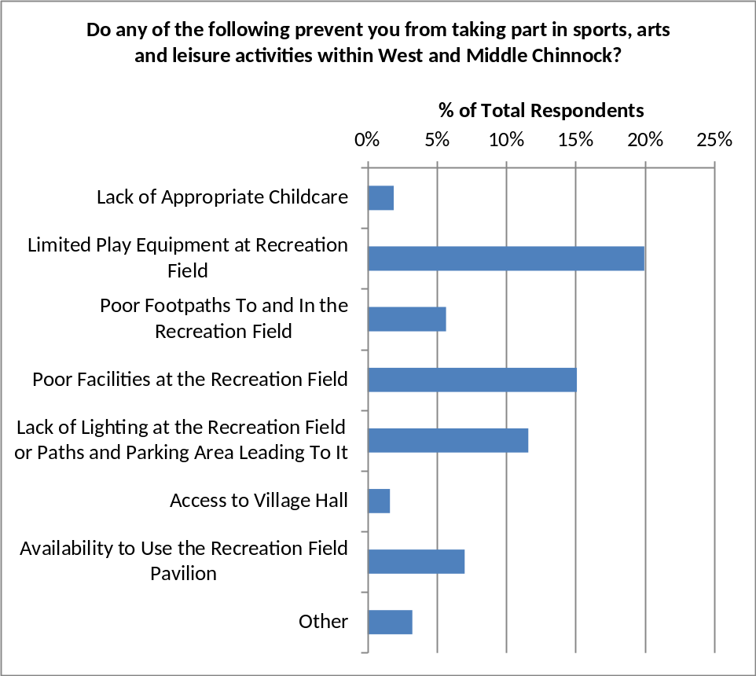

The principal reasons for not taking part in activities concern the lack of or quality of facilities and access to the Recreation Ground.

Regarding where activities are done, the following charts address leisure walking, walking the dog, playing outdoors, riding bikes and riding skateboards/scooters.
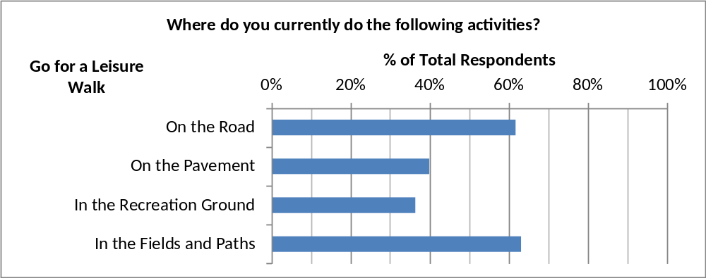

Of the listed activities, most respondents answered the leisure walk question, with a good spread across all types of location.

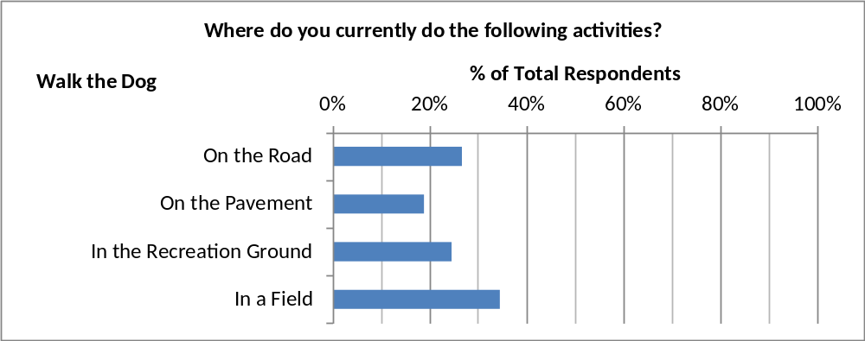

Walking the dog mirrors the leisure walking spread of locations.

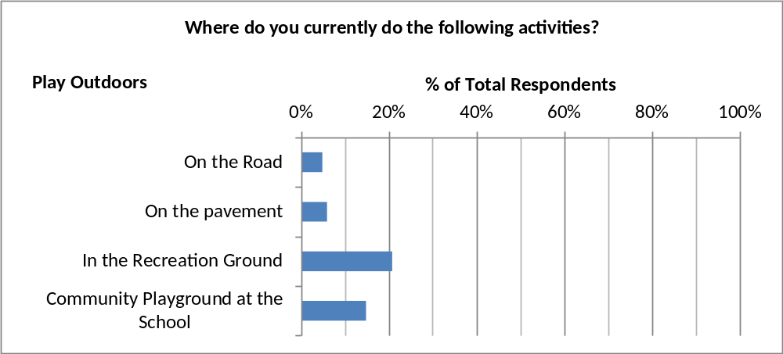

Playing outside is probably mostly aimed at younger respondents, with the Recreation Ground and Community Playground the most popular locations.
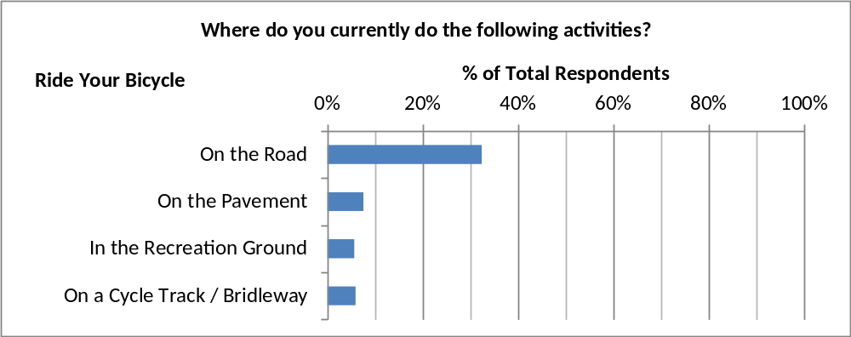

Bike riding is mainly carried out on the road.

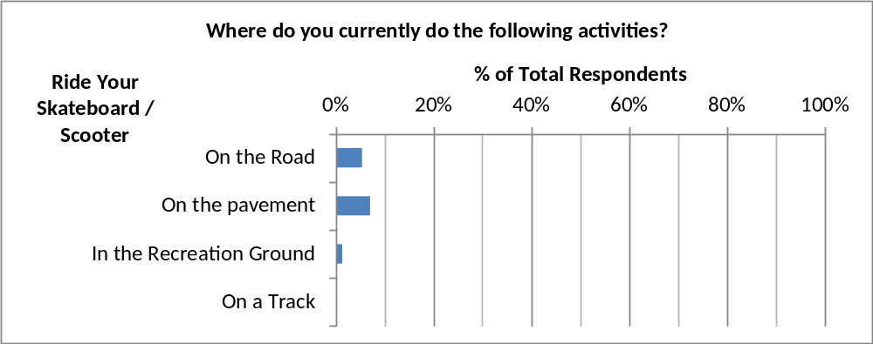

Skateboarding is again an activity undertaken by only a small proportion of respondents.

Volunteering

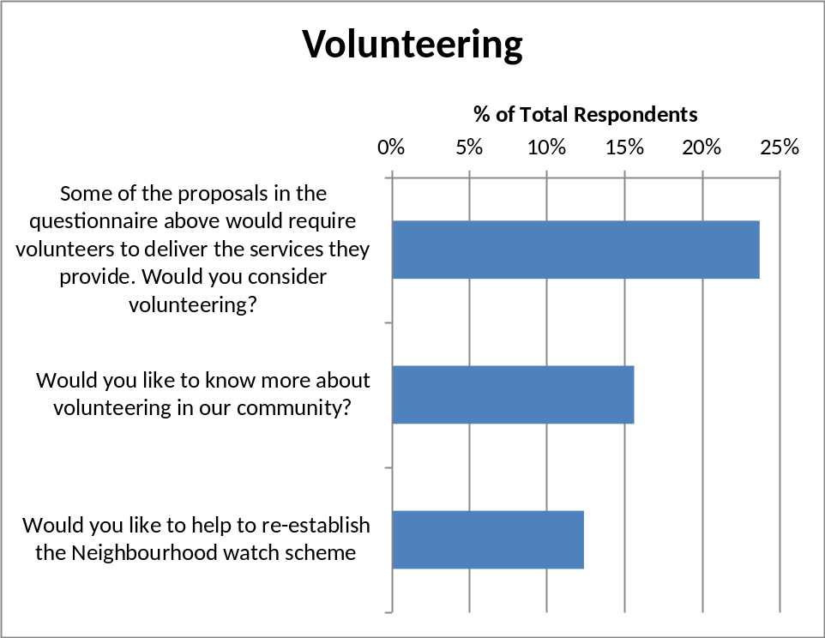

Asked about volunteering, a significant proportion of respondents (24%, = 88 people) indicated a willingness to help, including 12% (= 46 people) willing to help set up a Neighbourhood Watch scheme.

Community Spirit

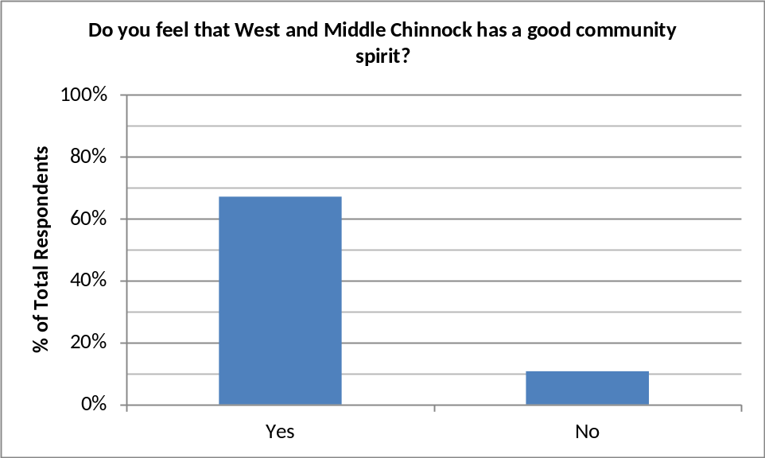

67% of respondents (86% of those that answered this question) feel that West & Middle Chinnock has a good community spirit. Although far fewer respondents think there is no community spirit, 11% (40 respondents), this is not an insignificant number.

These results broadly reflect the ‘interest in village events’ question (Section 3.1), which shows 90% interested and 10% not interested.

Housing
The housing question had a number of statements each requiring a ‘yes/no’ answer.

Unfortunately, one statement, concerning the building of new housing generally, was a ‘negative’ statement. From the answers to the other statements and textual comments, it is clear that several respondents had answered against their intentions; others may also have done so. Consequently, this sub-question has been removed from the analysis.

The other statements covered affordable homes, social/shared housing, and generally the number of new houses. These have been included in the chart below.

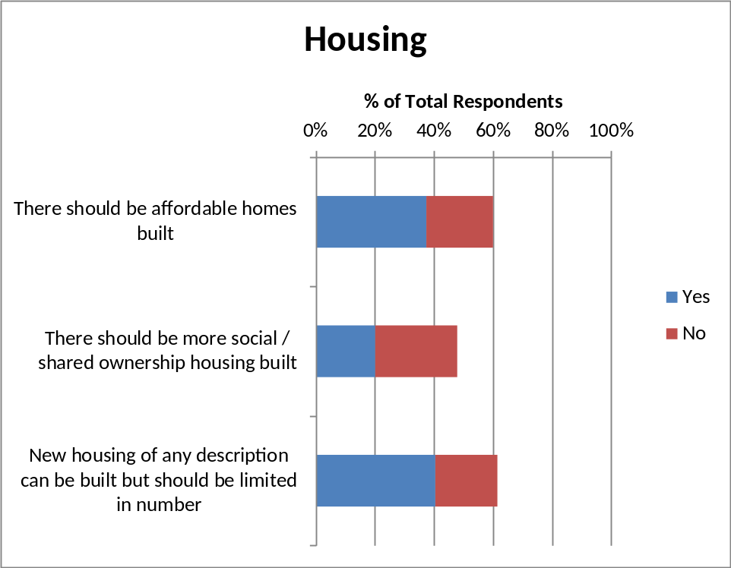

Around 50-60% of respondents answered these questions. Of these around 2:1 are in favour of ‘affordable homes’, but fewer than half are in favour of ‘social/shared ownership’ housing.

A ratio of 2:1 is in favour of any type of housing but limited in number.

Detailed Survey Conclusions
The objective of the survey was to elicit views on a range of community issues from as many residents as possible, of all ages.

There were 164 questionnaire returns (= 74% of Precept Properties), with 371 individual respondents, a very good return rate. Respondents cover a good spread of ages.

There is a huge amount of detailed information which can be analysed in detail and used to support specific projects or purposes as and when they arise. In particular, results can be broken down by respondent age group or by village location, where appropriate. And results from one question can be correlated with results from another if necessary.

Specific conclusions from the survey are as follows.

Activities, Community and Facilities

- 84% of respondents are interested in village events/activities. This is reflected by 86% feeling there is good community spirit.

- Knowledge of activities is mainly gained from the Parish Magazine (62%), Word of Mouth (61%) and Telegraph Poles (51%). Notice Boards are only used by 32%, and Online by less than 10%.

- 71% of respondents attend events at the Village Hall at least ‘occasionally’, 59% attend Pub events, 44% Church events and 37% School events.

- Most current village facilities are considered ‘important’ or ‘very important’ by over 80% of respondents.

- The Recreation Ground is the most used facility (41% use it at least ‘monthly’), followed by the Village Hall, Pub and Community Playground (around 20%).

- The most wanted improvement to facilities is new or better equipment at the Recreation Ground. This is followed by better footpaths to and in the Recreation Ground, a revamping of the current Village Hall, and the setting up of a Youth Club.

Transport

- 82% of respondents walk to village events (sometimes), 34% use the car.

- 43% of respondents encounter parking problems (lack of space or inconsiderate parking); 45% do not.

- Over 80% of respondents use the car for getting to places outside West & Middle Chinnock. Other modes of transport are used by less than 10% of respondents.

- If better transport services were available, 30% of respondents would use buses at least ‘monthly’; voluntary transport and car share would be used by only 5% of respondents.

Property

- The majority of properties are owned (127 = 85% of respondents who answered); only 22 (15%) are rented.

- Around 60% of respondents answered the question on new housing. Of these, ‘affordable homes’ and ‘new housing of any description (but restricted in number)’ were supported by a majority of around 2:1.

Safety

- Crime has been reported to the police by 10% of respondents; although this seems high, responses indicate this is spread over several years. Unsocial behaviour has been witnessed by 7%.

- 65% of respondents would like speed limits (13% would not); 59% would like Neighbourhood Watch (5% would not); but only 17% would like street lights (51% would not).

Part C

Proposed Action Plan

 | Plan | Comment | Immediate Actions
1. | General | Make survey results known to the Parish Council to utilise as appropriate. | 1a. Share the Community Plan with the Parish Council.  1b. Promote the results of the survey and highlight the need for volunteers to make the improvements a reality.
2. | Recreation Ground Development | Includes facilities at the Rec and access to the Rec. Will require a committee to be formed (this could be linked to the existing Recreational Association which manages the pavilion). | 2a. Discuss with the existing Recreational Association.  2b. Advertise the need to set up a significant project for development.  2c. Discuss parish funding with Parish Council.
3. | Village Hall Revamp | Village Hall Committee is already developing the hall; the survey results might help support their initiatives. | 3a. Inform the Village Hall Committee of the survey results details.
4. | Online & Notice Boards | Not greatly used for information; consider ways to increase use/awareness. Website managers to lead. | 4a. Discuss with the Parish Council and local website managers.
5. | Youth Activities | Includes the formation of a Youth Club. Will require a committee to be formed, involving youths. | 5a. Advertise the interest indicated by the survey.  5b. Ask for volunteers to manage.  5c. Seek SSDC support/advice.
6. | Neighbourhood Watch | It is believed that there is a scheme already operating in the parish. This needs better promotion. | 6a. Inform the current Neighbourhood Watch coordinator of the community interest.  6b. Advertise to set up an active committee.

